Release

What is Release?
# Source: AI Source: Provided by: [Data Path: Persons Table -> ID Column: 1, Name_En Column: Motasem Essam] -> From: [ChatGPT] on [2/15/2026]
A Release is a specific version of a software project that is ready for use, distribution, or deployment.
It usually corresponds to a tagged commit in Git (often an annotated tag) and may include binaries, source code, and release notes.

Key points
# Source: AI Source: Provided by: [Data Path: Persons Table -> ID Column: 1, Name_En Column: Motasem Essam] -> From: [ChatGPT] on [2/15/2026]
- Marks a stable version
  - Example: v1.0, v2.1.3
  - Indicates the project is ready for production or public use
- Based on a Git tag
  - Most releases are linked to annotated tags so they have metadata like version, date, and message
- Includes optional assets
  - Source code archives (.zip, .tar.gz)
  - Compiled binaries for different platforms
  - Release notes / changelog
- Common on platforms like GitHub or GitLab
  - GitHub → “Releases” tab
  - GitLab → “Tags & Releases”

Workflow example
# Source: AI Source: Provided by: [Data Path: Persons Table -> ID Column: 1, Name_En Column: Motasem Essam] -> From: [ChatGPT] on [2/15/2026]
- Complete a feature / milestone
- Merge into main branch
- Create an annotated tag:
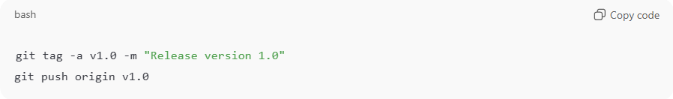
git tag -a v1.0 -m "Release version 1.0"
git push origin v1.0
- On GitHub/GitLab, create a Release from that tag
  - Add release notes
  - Attach binaries if needed
- Users or other developers can download that release or refer to it in CI/CD pipelines

Benefits of Releases
# Source: AI Source: Provided by: [Data Path: Persons Table -> ID Column: 1, Name_En Column: Motasem Essam] -> From: [ChatGPT] on [2/15/2026]
- Versioning → Users know which version they are using
- Distribution → Include binaries or compiled artifacts
- Tracking → Track milestones in the project history
- Integration → CI/CD pipelines can deploy specific releases automatically

💡 Memory trick:
# Source: AI Source: Provided by: [Data Path: Persons Table -> ID Column: 1, Name_En Column: Motasem Essam] -> From: [ChatGPT] on [2/15/2026]
Release = “official version” → tagged commit + optional binaries + release notes → ready for users ✅

Software Version Stages
# Source: AI Source: Provided by: [Data Path: Persons Table -> ID Column: 1, Name_En Column: Motasem Essam] -> From: [ChatGPT] on [2/15/2026]
Software is usually released in stages before it becomes fully stable and ready for production use. The most common stages are:
- Alpha
- Beta
- Release Candidate (RC)
- Stable / Production

1️⃣ Alpha Version
# Source: AI Source: Provided by: [Data Path: Persons Table -> ID Column: 1, Name_En Column: Motasem Essam] -> From: [ChatGPT] on [2/15/2026]
An alpha version is the earliest testing stage of the software.
Characteristics:
- Still under active development
- May contain many bugs
- Features may be incomplete
- Usually tested internally (developers or QA team)
Example version names:
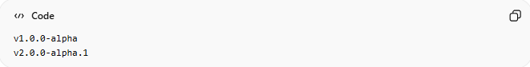
v1.0.0-alpha
v2.0.0-alpha.1
Think of alpha as:
“The software works, but it is not ready for users.”

2️⃣ Beta Version
# Source: AI Source: Provided by: [Data Path: Persons Table -> ID Column: 1, Name_En Column: Motasem Essam] -> From: [ChatGPT] on [2/15/2026]
A beta version comes after alpha.
Characteristics:
- Most features are complete
- More stable than alpha
- Still may contain bugs
- Often released to public users for testing
Example version names:
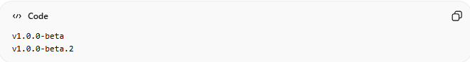
v1.0.0-beta
v1.0.0-beta.2
Think of beta as:
“Almost ready. Help us test it.”

3️⃣ Release Candidate (RC)
# Source: AI Source: Provided by: [Data Path: Persons Table -> ID Column: 1, Name_En Column: Motasem Essam] -> From: [ChatGPT] on [2/15/2026]
A Release Candidate (RC) is very close to the final version.
Characteristics:
- Feature-complete
- Only critical bug fixes allowed
- If no major issues are found, it becomes the final release
Example:
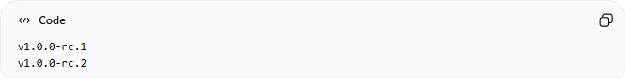
v1.0.0-rc.1
v1.0.0-rc.2
Think of RC as:
“This could be the final version if no serious bugs are found.”

4️⃣ Stable / Production Version
# Source: AI Source: Provided by: [Data Path: Persons Table -> ID Column: 1, Name_En Column: Motasem Essam] -> From: [ChatGPT] on [2/15/2026]
The production version is the final, fully tested version that is safe for users.
It is usually called:
- Stable version
- Production release
- General Availability (GA)
- Final release
Important:
It does NOT have labels like:
- alpha
- beta
- rc
Example:
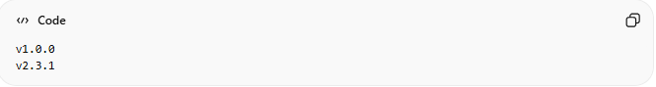
v1.0.0
v2.3.1
If there is no suffix (like -alpha or -beta), it usually means:
👉 This is the production-ready version.

📊 Full Version Flow Example
# Source: AI Source: Provided by: [Data Path: Persons Table -> ID Column: 1, Name_En Column: Motasem Essam] -> From: [ChatGPT] on [2/15/2026]
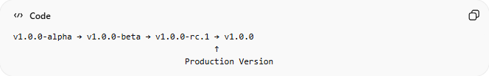
v1.0.0-alpha → v1.0.0-beta → v1.0.0-rc.1 → v1.0.0
↑
Production Version

🔎 Simple Comparison
# Source: AI Source: Provided by: [Data Path: Persons Table -> ID Column: 1, Name_En Column: Motasem Essam] -> From: [ChatGPT] on [2/15/2026]
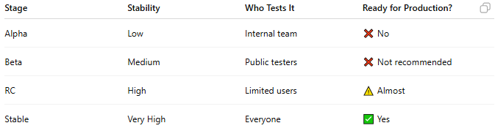
Stage | Stability | Who Tests It | Ready for Production?
Alpha | Low | Internal team | ❌ No
Beta | Medium | Public testers | ❌ Not recommended
RC | High | Limited users | ⚠️ Almost
Stable | Very High | Everyone | ✅ Yes

🚀 Summary
# Source: AI Source: Provided by: [Data Path: Persons Table -> ID Column: 1, Name_En Column: Motasem Essam] -> From: [ChatGPT] on [2/15/2026]
- Alpha = Early development testing
- Beta = Public testing version
- RC = Final testing stage
- Stable / Production = Official release for users

Release Assets

📦 What Are Release Assets?
# Source: AI Source: Provided by: [Data Path: Persons Table -> ID Column: 1, Name_En Column: Motasem Essam] -> From: [ChatGPT] on [2/15/2026]
Assets are downloadable files attached to a release.
They usually contain:
- The packaged source code
- Compiled application files (binaries)
- Installers
- Documentation
In simple terms:
Assets are the actual files users download for that version.

📦 What a Bundle Is
# Source: AI Source: Provided by: [Data Path: Persons Table -> ID Column: 1, Name_En Column: Motasem Essam] -> From: [ChatGPT] on [2/15/2026]
In software, a bundle is basically a package that contains multiple files or components together as one unit. It’s a way to organize and distribute code, resources, or applications.
Let me break it down clearly:

📦 What a Bundle Is
# Source: AI Source: Provided by: [Data Path: Persons Table -> ID Column: 1, Name_En Column: Motasem Essam] -> From: [ChatGPT] on [2/15/2026]
A bundle is:
- A collection of files grouped together
- Often compressed to save space
- Used to distribute or deploy software easily
Think of it as putting a bunch of items into one box so you can move them or share them together.

🖇 Examples of Bundles
# Source: AI Source: Provided by: [Data Path: Persons Table -> ID Column: 1, Name_En Column: Motasem Essam] -> From: [ChatGPT] on [2/15/2026]
- Archive Files
  - .zip → Bundles + compresses files
  - .tar → Bundles files (no compression)
  - .tar.gz → Bundles + compresses with gzip
  - .tar.bz2 → Bundles + compresses with bzip2
- Software Packages
  - .jar → Java Archive (bundles Java classes + resources)
  - .app → macOS app bundle (contains app code, resources, icons)
  - .exe installer → Windows installer bundling program files
- Web Development
  - JavaScript/TypeScript bundles: tools like Webpack combine multiple JS files into one file for easier deployment

🔧 Why Bundles Are Useful
# Source: AI Source: Provided by: [Data Path: Persons Table -> ID Column: 1, Name_En Column: Motasem Essam] -> From: [ChatGPT] on [2/15/2026]
- Easy to distribute → one file instead of hundreds
- Keeps files organized → all dependencies together
- Optimized for performance → compressed bundles are smaller and faster to download
- Version control & releases → archives of code snapshots (like GitHub releases) are bundles

🎯 In the Context of Git Releases
# Source: AI Source: Provided by: [Data Path: Persons Table -> ID Column: 1, Name_En Column: Motasem Essam] -> From: [ChatGPT] on [2/15/2026]
When GitHub or GitLab generates:
- project-v1.0.0.zip
- project-v1.0.0.tar.gz
These are bundles of your source code at that tag, meaning all the files are packaged together so users can download and use them without needing the full Git repository.

🗂 Common Archive Formats
# Source: AI Source: Provided by: [Data Path: Persons Table -> ID Column: 1, Name_En Column: Motasem Essam] -> From: [ChatGPT] on [2/15/2026]
GitHub and GitLab automatically generate source code archives for each release tag, usually in multiple formats:
- .zip
- .tar
- .tar.gz
- .tar.bz2
These are compressed snapshots of your project at that tagged version.

1️⃣ .zip
# Source: AI Source: Provided by: [Data Path: Persons Table -> ID Column: 1, Name_En Column: Motasem Essam] -> From: [ChatGPT] on [2/15/2026]
Example:
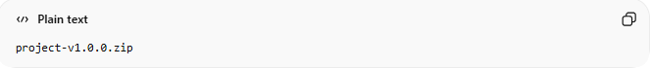
project-v1.0.0.zip
- Bundles and compresses files into a single archive
- Very common on Windows
- Easy to extract for non-technical users
- Extract on:
  - Windows: Right-click → Extract
  - Mac: Double-click
  - Linux: unzip project-v1.0.0.zip

2️⃣ .tar
# Source: AI Source: Provided by: [Data Path: Persons Table -> ID Column: 1, Name_En Column: Motasem Essam] -> From: [ChatGPT] on [2/15/2026]
Example:
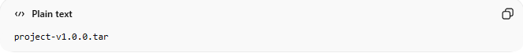
project-v1.0.0.tar
- TAR = Tape Archive
- Bundles multiple files into one, but does NOT compress
- Common on Linux for packaging
- Extract with:
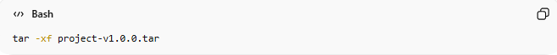
tar -xf project-v1.0.0.tar
Think of it as putting files into a container without shrinking them.

3️⃣ .tar.gz (or .tgz)
# Source: AI Source: Provided by: [Data Path: Persons Table -> ID Column: 1, Name_En Column: Motasem Essam] -> From: [ChatGPT] on [2/15/2026]
Example:
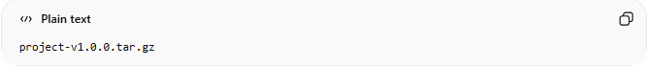
project-v1.0.0.tar.gz
- Combines .tar with gzip compression
- Very common in Linux/macOS
- Smaller than .tar because it compresses the bundle
- Extract with:
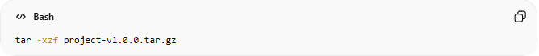
tar -xzf project-v1.0.0.tar.gz
Bundle first → compress → smaller file.

4️⃣ .tar.bz2
# Source: AI Source: Provided by: [Data Path: Persons Table -> ID Column: 1, Name_En Column: Motasem Essam] -> From: [ChatGPT] on [2/15/2026]
Example:
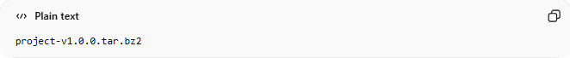
project-v1.0.0.tar.bz2
- Combines .tar with bzip2 compression
- Usually achieves better compression than gzip
- Common in Linux distributions and open-source projects
- Extract with:
tar -xjf project-v1.0.0.tar.bz2
Bundle first → compress harder → smaller file.

📊 Quick Comparison of Formats
# Source: AI Source: Provided by: [Data Path: Persons Table -> ID Column: 1, Name_En Column: Motasem Essam] -> From: [ChatGPT] on [2/15/2026]
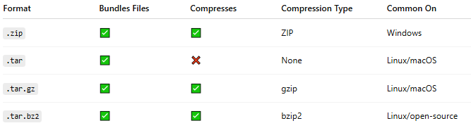
Format | Bundles Files | Compresses | Compression Type | Common On
.zip | ✅ | ✅ | ZIP | Windows
.tar | ✅ | ❌ | None | Linux/macOS
.tar.gz | ✅ | ✅ | gzip | Linux/macOS
.tar.bz2 | ✅ | ✅ | bzip2 | Linux/open-source

🧩 Why Multiple Formats?
# Source: AI Source: Provided by: [Data Path: Persons Table -> ID Column: 1, Name_En Column: Motasem Essam] -> From: [ChatGPT] on [2/15/2026]
- Different platforms and users prefer different formats
- Windows → .zip (easy for general users)
- Linux/macOS → .tar.gz or .tar.bz2 (developers, servers)
- Raw packaging → .tar (no compression, just bundling)

🔧 Can You Upload Custom Assets?
# Source: AI Source: Provided by: [Data Path: Persons Table -> ID Column: 1, Name_En Column: Motasem Essam] -> From: [ChatGPT] on [2/15/2026]
Yes.
Besides automatic source archives, you can upload:
- .exe (Windows installer)
- .dmg (Mac installer)
- .jar
- Compiled binaries
- Docker images (linked)
- Documentation PDFs
Those are also called release assets.

📝 Important Notes
# Source: AI Source: Provided by: [Data Path: Persons Table -> ID Column: 1, Name_En Column: Motasem Essam] -> From: [ChatGPT] on [2/15/2026]
- The automatic generated release archives .zip, .tar, .tar.gz, .tar.bz2 files:
  - Are generated from your Git tag
  - Do NOT include the .git folder
  - Are just snapshots of your code
- Users download assets depending on their operating system or preference
- Developers often create their own assets for compiled binaries or platform-specific packages

🎯 Simple Example
# Source: AI Source: Provided by: [Data Path: Persons Table -> ID Column: 1, Name_En Column: Motasem Essam] -> From: [ChatGPT] on [2/15/2026]
If you release v1.0.0:
Assets might include:
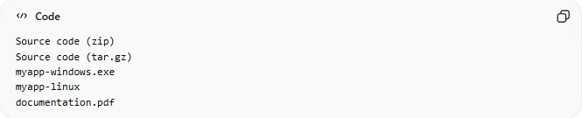
Source code (zip)
Source code (tar.gz)
myapp-windows.exe
myapp-linux
documentation.pdf
Users download what they need.

🎯 Summary
# Source: AI Source: Provided by: [Data Path: Persons Table -> ID Column: 1, Name_En Column: Motasem Essam] -> From: [ChatGPT] on [2/15/2026]
- Assets = downloadable files for a release
- Archives include:
  - .zip → Windows-friendly, compressed
  - .tar → Linux-friendly, uncompressed bundle
  - .tar.gz → Linux/macOS, compressed with gzip
  - .tar.bz2 → Linux/open-source, compressed with bzip2
- Custom assets (executables, documentation) can also be added
- Assets represent the exact state of code at a Git tag for users to download and use

